ZH,
REPORT OF JOINT INVESTIGATION VISIT TO OLD 20” KOLO-CREEK-RUMUEKPE P/LINE @ OPKOROWO COMMUNITY (INC.NO.2023_1800550) ON DECEMBER 29, 2023
COMPANY ADDRESS: Shell Petroleum Development Company Ltd., Rumuobiakani, Port Harcourt
SITE ADDRESS: Old 20” Kolo-Creek-Rumuekpe P/Line @ Okporowo Community Ahoada East LGA, Rivers State.
SITE COORDINATES: N4.971211 E6.43029

JIV DATE/TIME: December 29, 2023
JIV TEAM:
- Pius Okon NOSDRA
- Dr. Tombari Bodo RSMENVE
- Dublin-Green Sontonye NUPRC
SITE CONTACTS:
- Bademosi A. Omolayo SPDC Governance
- Obinna Ihezie SPDC PE
- Runyi Bassey SPDC HSE
- Kingdom Isaac Okporowo Community Rep.
PURPOSE OF INSPECTION: The inspection was carried out as a response to the theft point installation incident reported to the Agency. To ascertain the cause of the incident, areas impacted (if any), type and volume of contaminant released into the environment (if any) and make appropriate recommendations.
COMPLIANCE HISTORY: The non-leak theft point was discovered on December 25, 2023 and was reported to the Agency on December 25, 2023 in line with extant Regulations. A Joint Investigation Visit (JIV) was thereafter carried out accordingly.
OPENING CONFERENCE: Team members were conveyed from Port Harcourt to the incident location by the Operating Company. Introduction of all personnel on board (POB) was done first on arrival. A tool box meeting was thereafter carried out to analyze the job description and associated hazards with a view to ensuring safety of POB and minimal environmental impact.
WALK THROUGH INSPECTION:
- The JIT observed recent excavation activities within the incident point.
- The incident point was non-leak at the time of investigation
- The incident was within the company right of way at the time of investigation.
- Stained vegetation around the incident area due to previous bunkering activities was observed by the investigation team at the time of inspection.
- On excavation, the JIT observed a tampered previous clamp point with water leak from 3 O’clock position done by unknown person(s).
CLOSING CONFERENCE: Repair was carried out immediately after JIV exercise.
COMPLIANCE CONCERN: There was no observed violation of the Agency’s Enabling Act and Regulations S.I 25 & 26.
RECORD OF INSPECTION:
- JIV Notification letter
- Agency’s JIV Form
- The Operator’s JIV Form
STILL PHOTOGRAPHS:
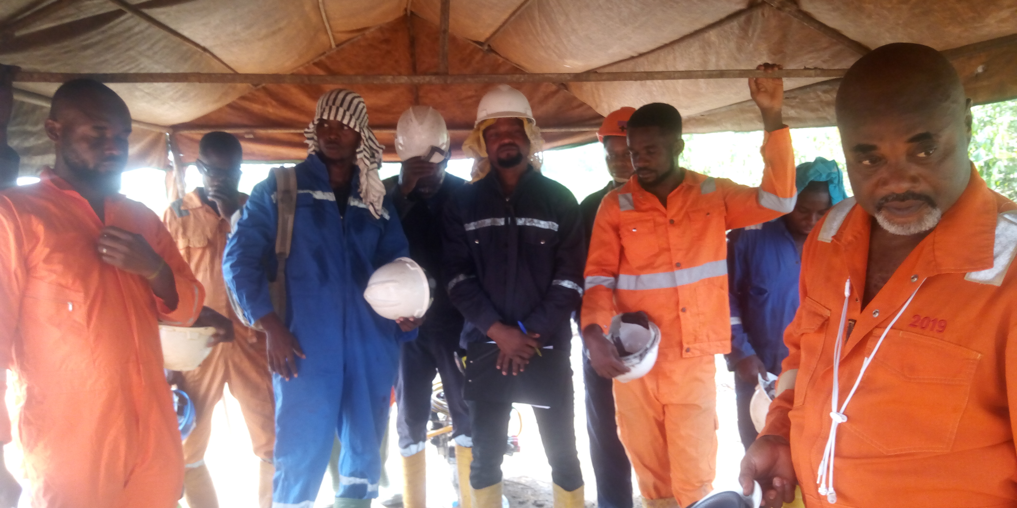
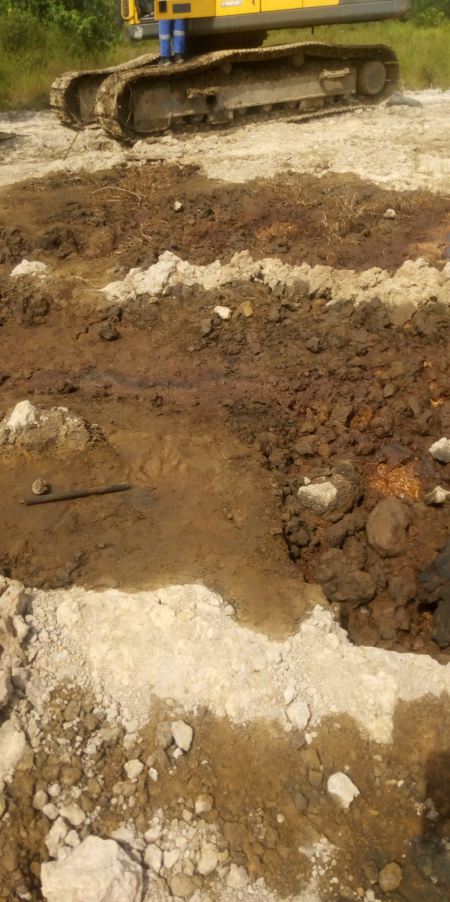
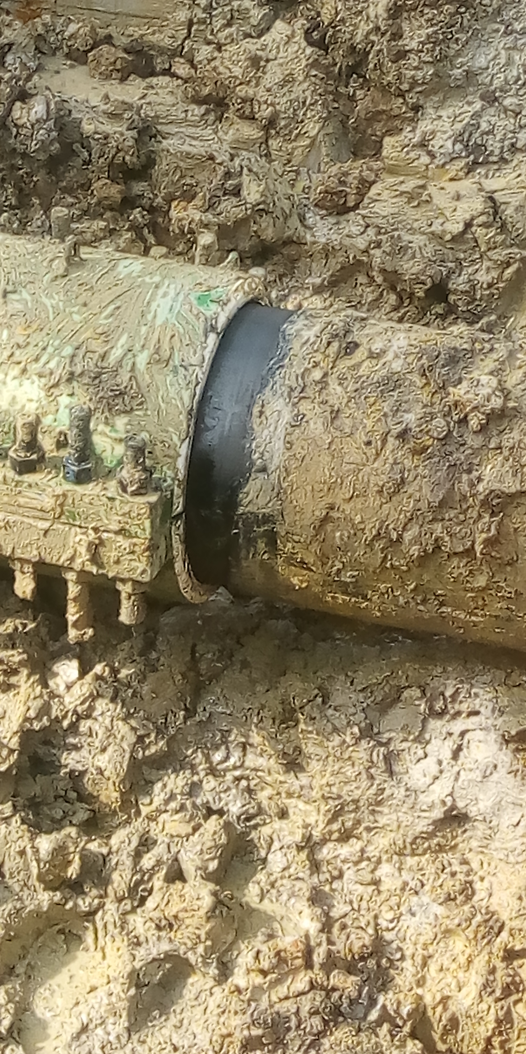
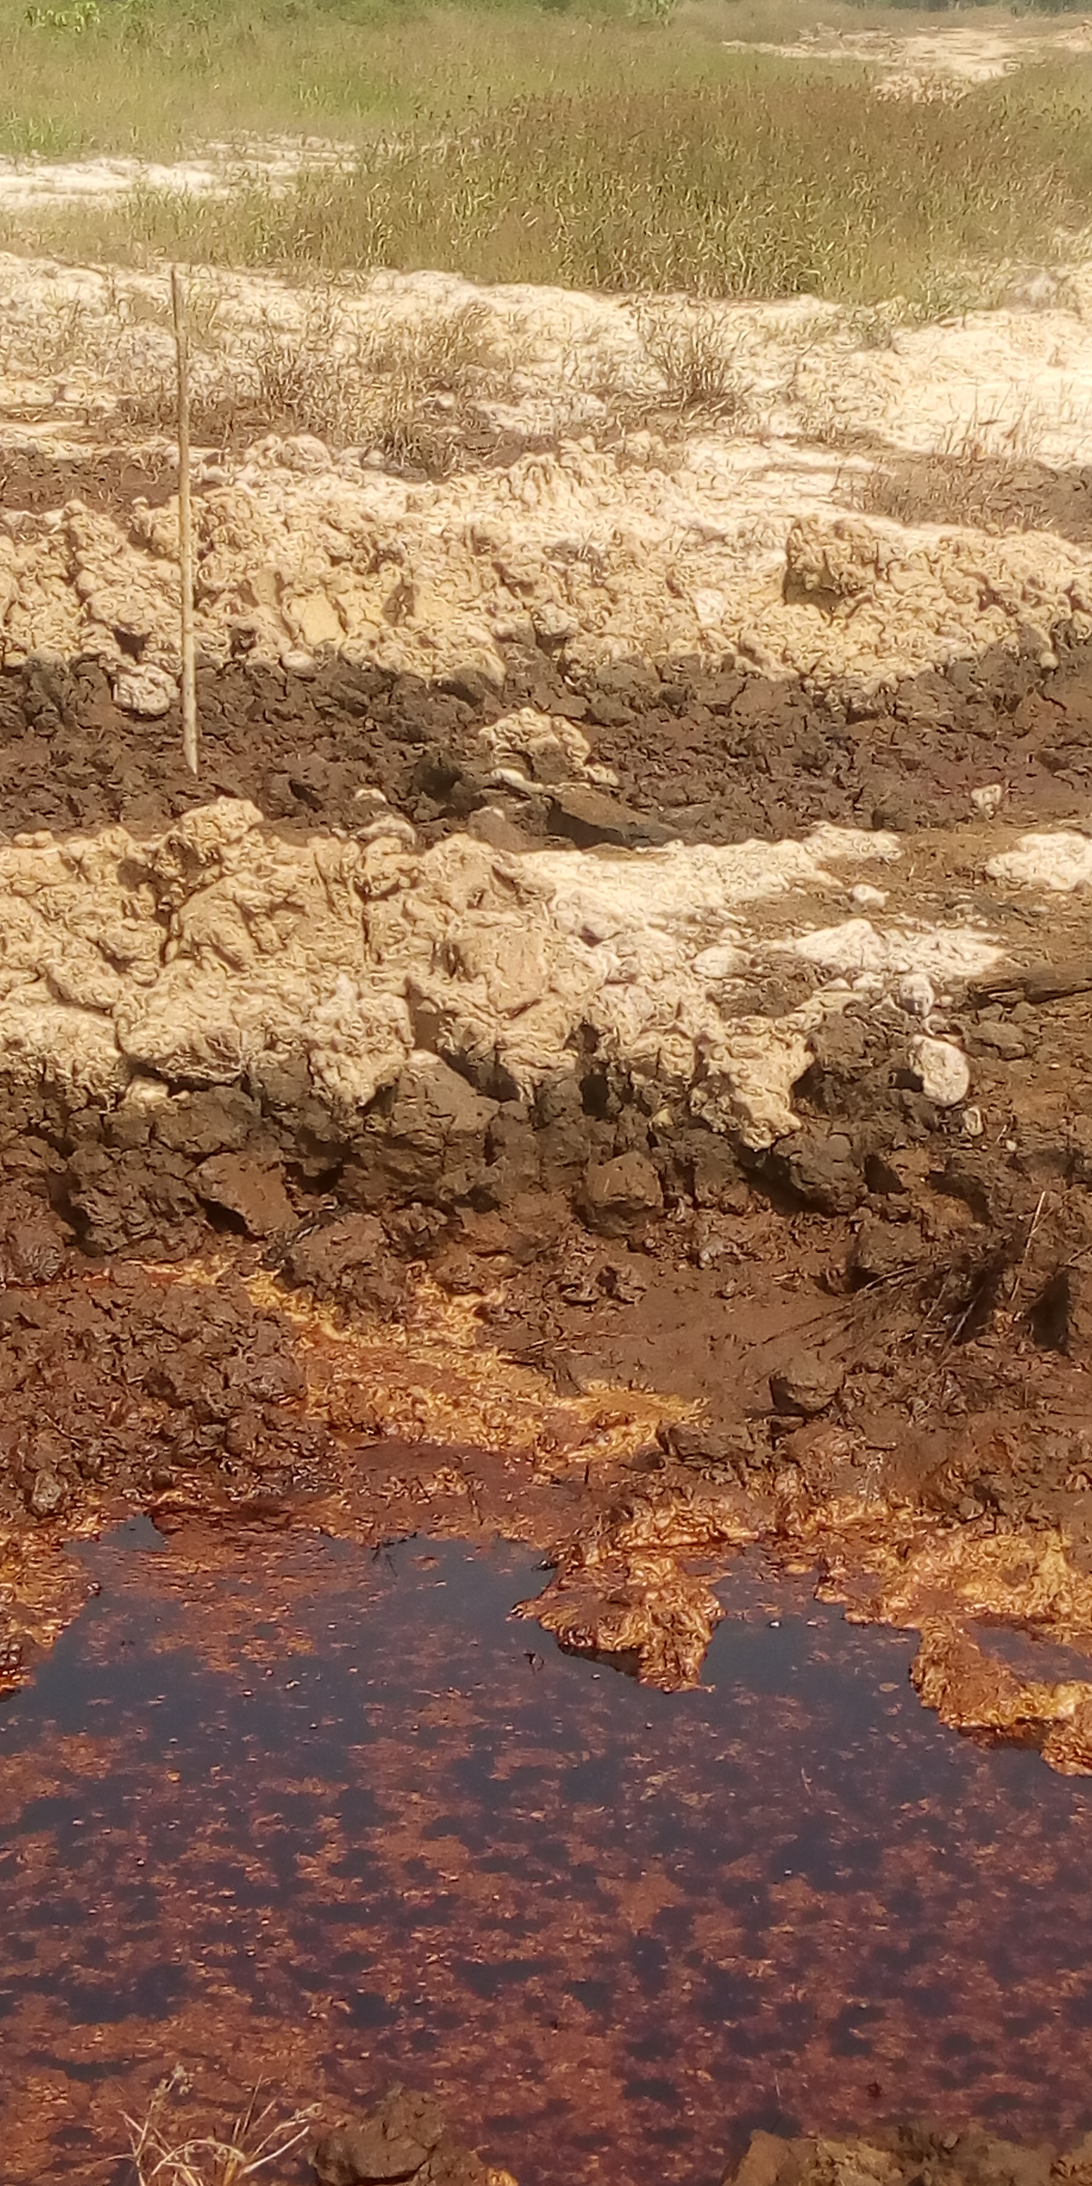

Pix: showing original state of incident point, a tampered previous clamp point with water leak from 3 O’clock position done by unknown person(s), stained vegetation within the incident area, and JIT during tool box meeting.
RECOMMENDATIONS:
- The repair of the incident point was carried out at the end of the JIV.
- The Agency should carry out public enlightenment campaigns on the dangers of oil theft, illegal refineries and the attendant spillages on the environment.

Pius Okon
PTO 1
January 02, 2024

